Cheltenham and County Harriers present

The Bugatti Beer Race 10k

Sponsored by:
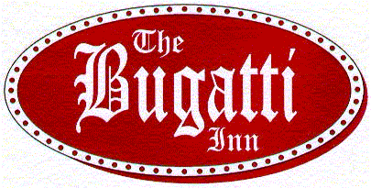

Wednesday 3rd August 2005 at 7.30 pm

from the Bugatti Inn, Gretton, near Winchcombe

A Gloucestershire County Series Race
under AAA rules

ENTRY LIMIT 400 – NO ENTRIES ON THE DAY

ENTER NOW TO AVOID DISAPPOINTMENT!

A scenic & undulating course finishing at the Bugatti Inn
T-shirt to all finishers, plus beer & hot dog or burger
Limited parking
 Prizes subject to entries
For further details, contact the Race Director (01242 576583)
or visit our website http://cheltenhamharriers.co.uk/
-------------------------------------------------------------------------------------------------

ENTRY FORM
Closing date 30 July or when entry limit reached
Please complete this section and return with payment and a large SAE to:
Andy McCoy, 20 Pumphreys Road, Charlton Kings CHELTENHAM GL53 8DD

FULL NAME (CAPITALS) ___________________________________________________________________________

ADDRESS________________________________________________________________________________________

______________________________________________________________POST CODE________________________

SEX (M/F)________________ AGE on 3rd AUGUST 2005 (minimum age 17 years) _____________________________

CLUB____________________________________________________________________________________________

Payment enclosed – £6.50 (£7.50 unattached) Cheques payable to Cheltenham and County Harriers

I understand that I participate in the Bugatti Beer Race at my own risk and that the organisers and ‘The Bugatti’ will not be responsible for any injuries sustained by me or for any property lost on the premises or on the course.

SIGNED______________________________________________ DATE_________________________________

